Supplemental data.
Table 2. Checkerboard analysis of pre-existing and newly developing lesions

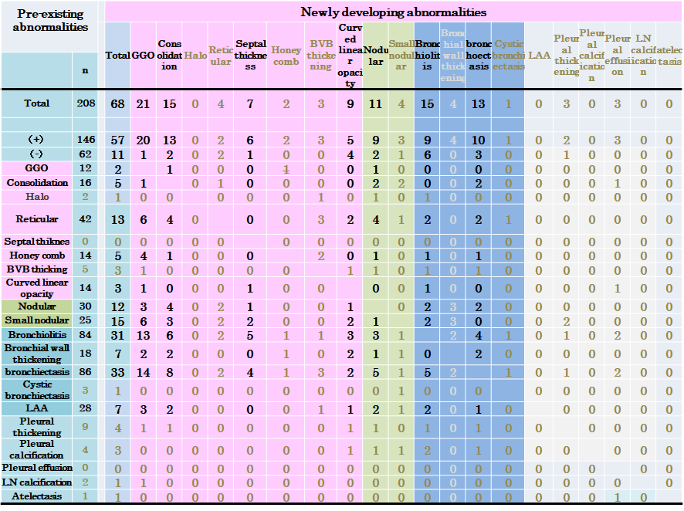

For analysis, preexisting lesions (# of cases with lesion > 10)and new lesions (# of cases>5) were used.

